Introduction
International student mobility is an important dimension of global education and talent exchange. This study examines how the COVID-19 pandemic and subsequent travel restrictions affected outbound student flows from 31 Asian countries (China, India, Kazakhstan, Vietnam, Afghanistan, Bangladesh, Bhutan, Brunei, Cambodia, Indonesia, Laos, Malaysia, Maldives, Burma/Myanmar, Nepal, Pakistan, Philippines, Singapore, Sri Lanka, Thailand, Timor-Leste, South Korea, North Korea, Hong Kong, Japan, Mongolia, Kyrgyzstan, Tajikistan, Turkmenistan, Uzbekistan and Macau) to two major destinations: the United States and Europe.
To better understand the broader context of student mobility, the analysis compares changes in Asian student enrollment in the United States with the corresponding enrollment trends in European higher education institutions, providing insight into how the policy shock may have altered incentives for international students. Using this policy as a natural experiment, the analysis employs a difference-in-differences (DiD) design. The approach compares changes in total Asian students in the Europe countries following the restrictions with concurrent enrollment changes in the United States, which serves as a comparison group unaffected by temporary CONID-19 Travel restrictions.
The main research question is: How did COVID-19 travel restrictions in 2020 affect the number of Asian students studying abroad in Europe (treatment group) compared to the United States (control group)?
The preliminary hypothesis is that student mobility to both Europe and the United States declined sharply in 2020 as a result of the COVID-19 pandemic and associated travel restrictions. However, the decline was expected to be greater for Europe, due to its stricter entry restrictions and the temporary suspension of non-essential travel and visa issuance across most EU countries between March and June 2020. As travel bans were gradually lifted and universities reopened, international student mobility was expected to recover beginning in 2021, with the total number of students slowly increasing as visa processing resumed.
Data and Methods
The main data sources of this paper will be from Eurostat data (for Asian students enrolled in European higher education institutions) and IIE Open Doors data (for Asian students studying in the United States) with the World Bank Group for economic and social indicators (GDP, unemployment rate, net immigration) for students’ countries of origin covering the years 2014–2023. The combined dataset includes 31 Asian countries students coming from, each with annual totals of students studying abroad in the United States and Europe.
A difference-in-differences (DiD) design is appropriate for this study because it allows for causal
Inference in a natural experiment setting. This approach aligns closely with the methodological reasoning outlined by Riegg (2008), who emphasized that estimating causal effects in education policy research is often complicated by omitted variable bias and non-random treatment assignment. She notes that “the problem of omitted variable bias arises because states that implement certain financial aid policies and students who receive financial aid are typically self-selected” (p. 331). In other words, entities that adopt a policy often differ systematically from those that do not. Cellini highlights that the difference-in-differences method offers a practical solution because it “goes one step further than the fixed effects approach by adding an additional level of variation,” allowing researchers to “compare the within-state changes over time between states that adopted the policy and those that did not” (p.342–343). This layered comparison helps remove bias from unobserved, time-invariant factors that would otherwise confound causal estimates.
Before estimating the difference-in-differences model, I excluded China, India, and Vietnam from the dataset. These three countries collectively account for a disproportionately large share of Asian students studying abroad and thus exert substantial influence on overall regional trends. Because changes in their domestic policies or international mobility patterns could dominate the variation in total student flows, including them would make it difficult to observe representative regional effects across the remaining countries. Excluding these outliers allows for a more balanced comparison and improves the interpretability of the model.
After filtering out these countries, I aggregated the remaining data across 28 Asian countries, calculating the year-over-year percentage change in the total number of students studying in Europe and the United States. The resulting visualization (Figure 1) shows clear differences in the trajectories of student mobility across the two destinations. A sharp decline is visible in 2020, corresponding with the onset of COVID-19 travel restrictions, followed by partial recovery in subsequent years. The dashed vertical line at 2020 highlights this policy shock event.
To identify changes over time, I calculated the year-over-year percentage change in total student numbers by country and destination. Next, I created binary variables to distinguish between the country of origin (31 Asian countries) and the study destination (Europe = 0, United States = 1).
We then conducted a simple linear regression including all 31 countries to examine the overall trend and assess whether the change in total Asian students studying in Europe and the United States followed parallel pre-trend patterns before the 2020 policy shock. After estimating the model, we reviewed the regression coefficients and p-values to evaluate the statistical significance of the relationship and checked the normality of residuals to ensure model validity.
Finally, we divided the dataset into pre-policy (2014–2019) and post-policy (2020–2023) periods to compare coefficients across the two phases, allowing interpretation of the changes in student mobility patterns before and after the onset of the COVID-19 travel restrictions.
Early results
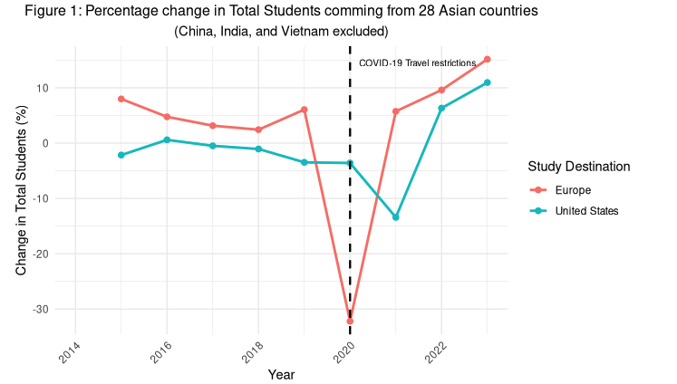
From Figure 1, we can see that both destinations exhibited relatively stable trends in percentage change of international Asian students. However, in 2020, there was a sharp decline in total students for European countries, while the United States experienced a slight increase in total students compared to previous year. This pattern aligns with the preliminary hypothesis that European countries experienced stricter and more prolonged travel and visa restrictions than the United States, where there are some exemptions for F and J visas. After 2020, the United States showed a drop in 2021 but then recovered and grew quickly in 2022, while Europe rebounded even more quickly, with both destinations showing positive growth rates again by 2022–2023. This divergence suggests that although Europe was initially more affected by the travel ban, it may have implemented more aggressive reopening and student mobility recovery measures in the subsequent years.
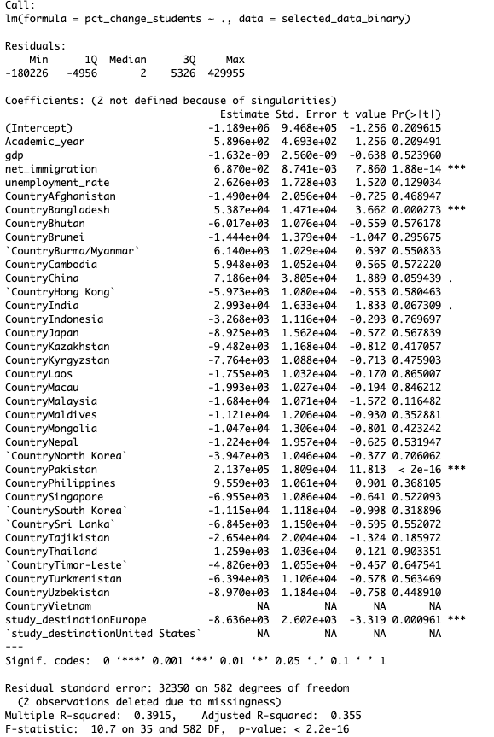
Overall, the strong predictors are net_immigration, CountryBangladesh, CountryPakistan and study_destinationEurope with significant p-value (p < 0.05) while other countries show positive/negative effects but are mostly not statistically significant. Furthermore, Adjusted R-squared (0.335) indicates around 35% of variation, which means that is room for improvement by adding more social/economic indicators later. Because the majority of predictors in here are statistically insignificant, we will need to plot Residuals vs. Fitted values plot to evaluate the overall fit of a regression model
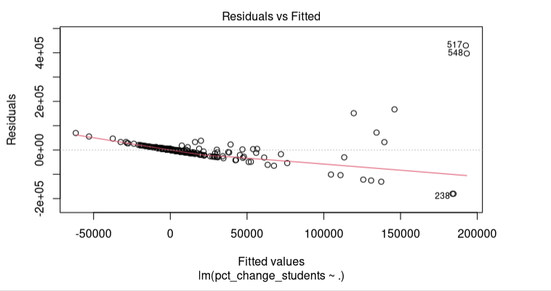
Based on the Residuals vs Fitted plot of linear regression model between percentage change in total Asian students (pct_change_students) and all predictors in the dataset, the variance of the residuals is clearly not constant as the fitted line directs negative direction. For low fitted values (left side, below 50,000), the residuals are tightly clustered near 0 in majority. But for high fitted values (right side, above 100,000), the residuals become very spread out gradually, which suggests that the model's errors are larger and more variable for observations where the model predicts higher values and indicates that standard errors and significance tests (p-values) are unreliable.
Conclusion
Overall, the difference-in-differences (DiD) may not be the best fit for this project based on Residuals vs Fitted plot above. However, there is still room for improvement to make it possible by using a logarithmic transformation (log) for the response variable (pct_change_students) which can stabilize variance and reduce the effect of outliers from the original model. After that, we will move on to dividing the dataset into pre-policy (2014–2019) and post-policy (2020–2023) periods to compare coefficients across the two phases to examine the casual impact of policy after taking account of social and economic indicators.
https://github.com/Ngan-Nguyen2004/DA401_Final_project.git
Riegg, S. K. (2008). Causal inference and omitted variable bias in financial aid research: Assessing
solutions. The Review of Higher Education, 31(3), 329-354.

